**Software Detailed Design**

**Report #4**

**Team Name:**

Mathematical Maestros

**Team Members:**

Jonathan Hasty

Jacob Coomes

Matthew Branstetter

**Breakdown of individual contributions**

*(subject to change over course of project)*

Jonathan Hasty

1. Team lead

2. Documentation

3. Coding

Jacob Coomes

1. Coding

2. Documentation

3. Testing

Matthew Branstetter

1. Coding

2. Documentation

3. Testing

Software Detailed Design

1. Data Design (Jonathan Hasty)

The data is stored in a relational database using SQLAlchemy. The fields for transmitting to and from the database are given in the following table.

|  |  |  |
| --- | --- | --- |
| Attribute Name | Attribute Type | Attribute Size |
| username | String | 16 |
| hashpassword | String | 80 |
| email | String | 30 |
| userid | Int | default |
| songid | Int | default |
| rating | Int | 5 |
| Id | Int | default |
| location | Int | 300 |
| emotion | String | 30 |
| steps | Int | 50 |
| AverageRating | Int | 5 |
| NumberRatings | Int | large |
| SumRatings | Int | large |

1. Architecture Design (Jonathan Hasty)

The software architecture is a client-server architecture composed of a React.js front end (client) and Python-Flask backend (server). The Flask backend will communicate with an SQLAlchemy database and fetch/serve data between the front end through REST api calls.

1. Interface Design (Jacob Coomes)

The first thing that happens when opening the website will be a sign-up/ login page. After the user sign-in they will be directed to the main page that will let the user ask the computer to create a computerized music that can be played, and if they like it they will be able to download it. The user will have to go to the bottom of the page to fill out a form that will help the computer know what type of music to make.

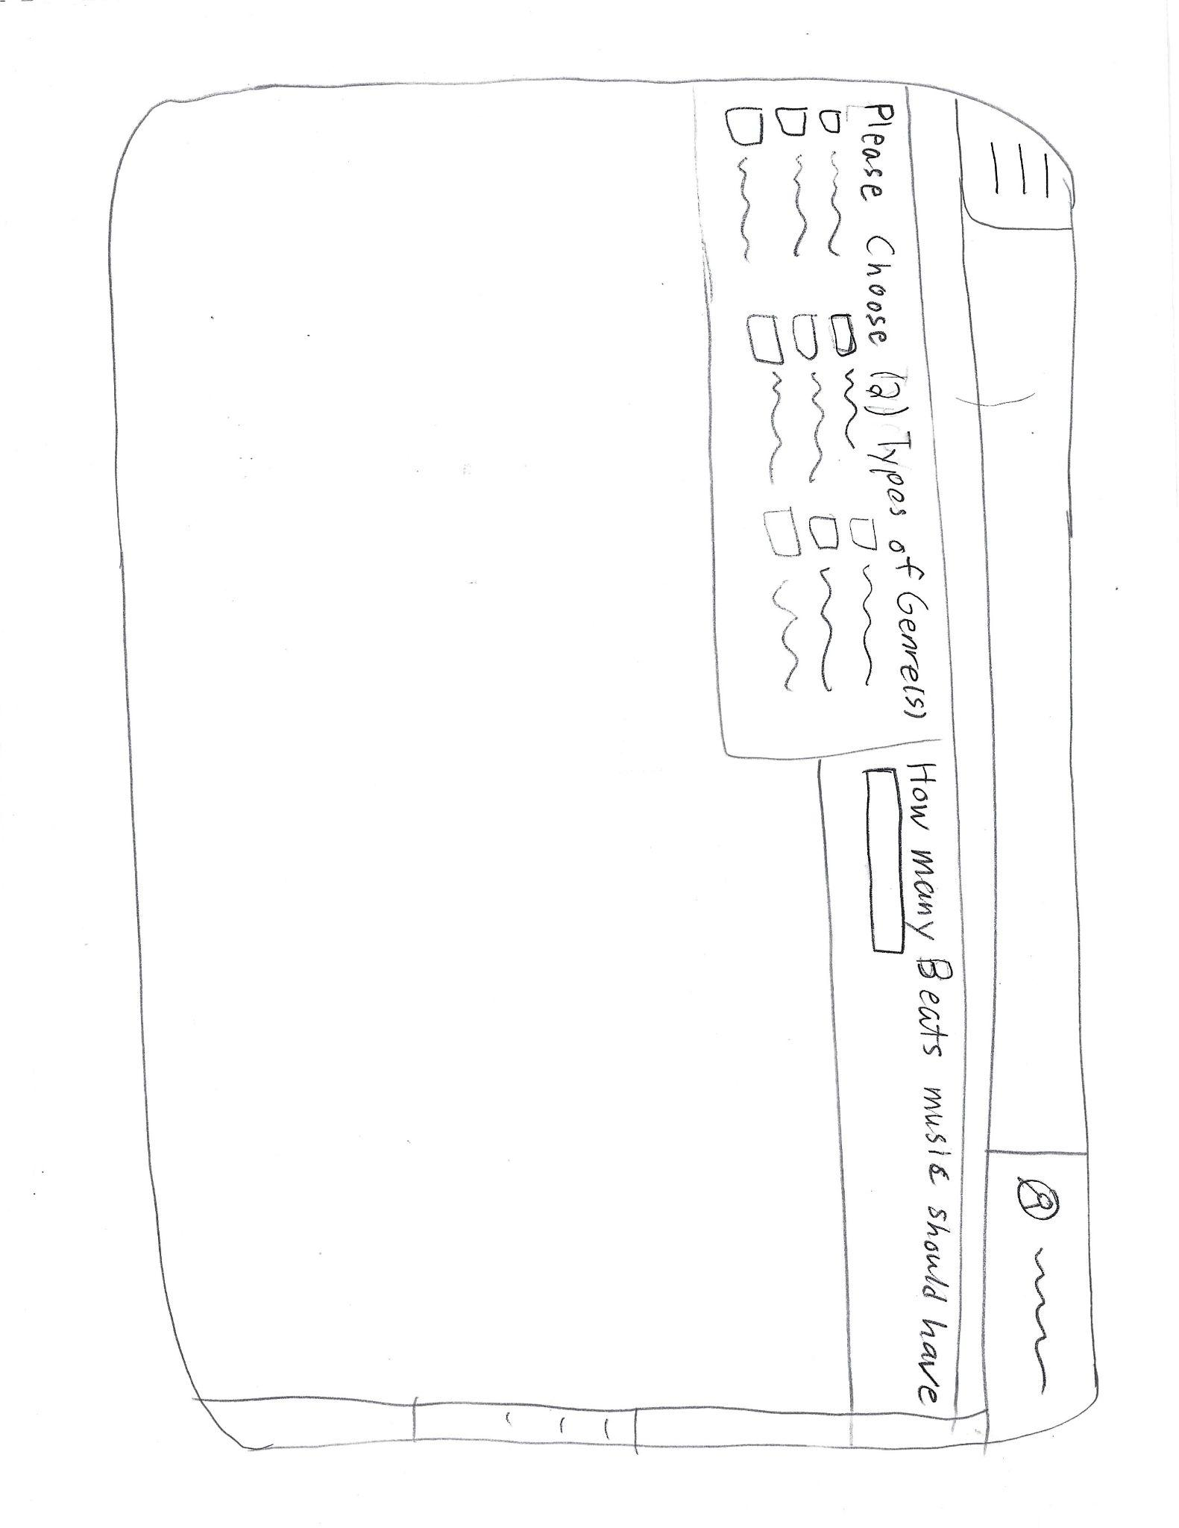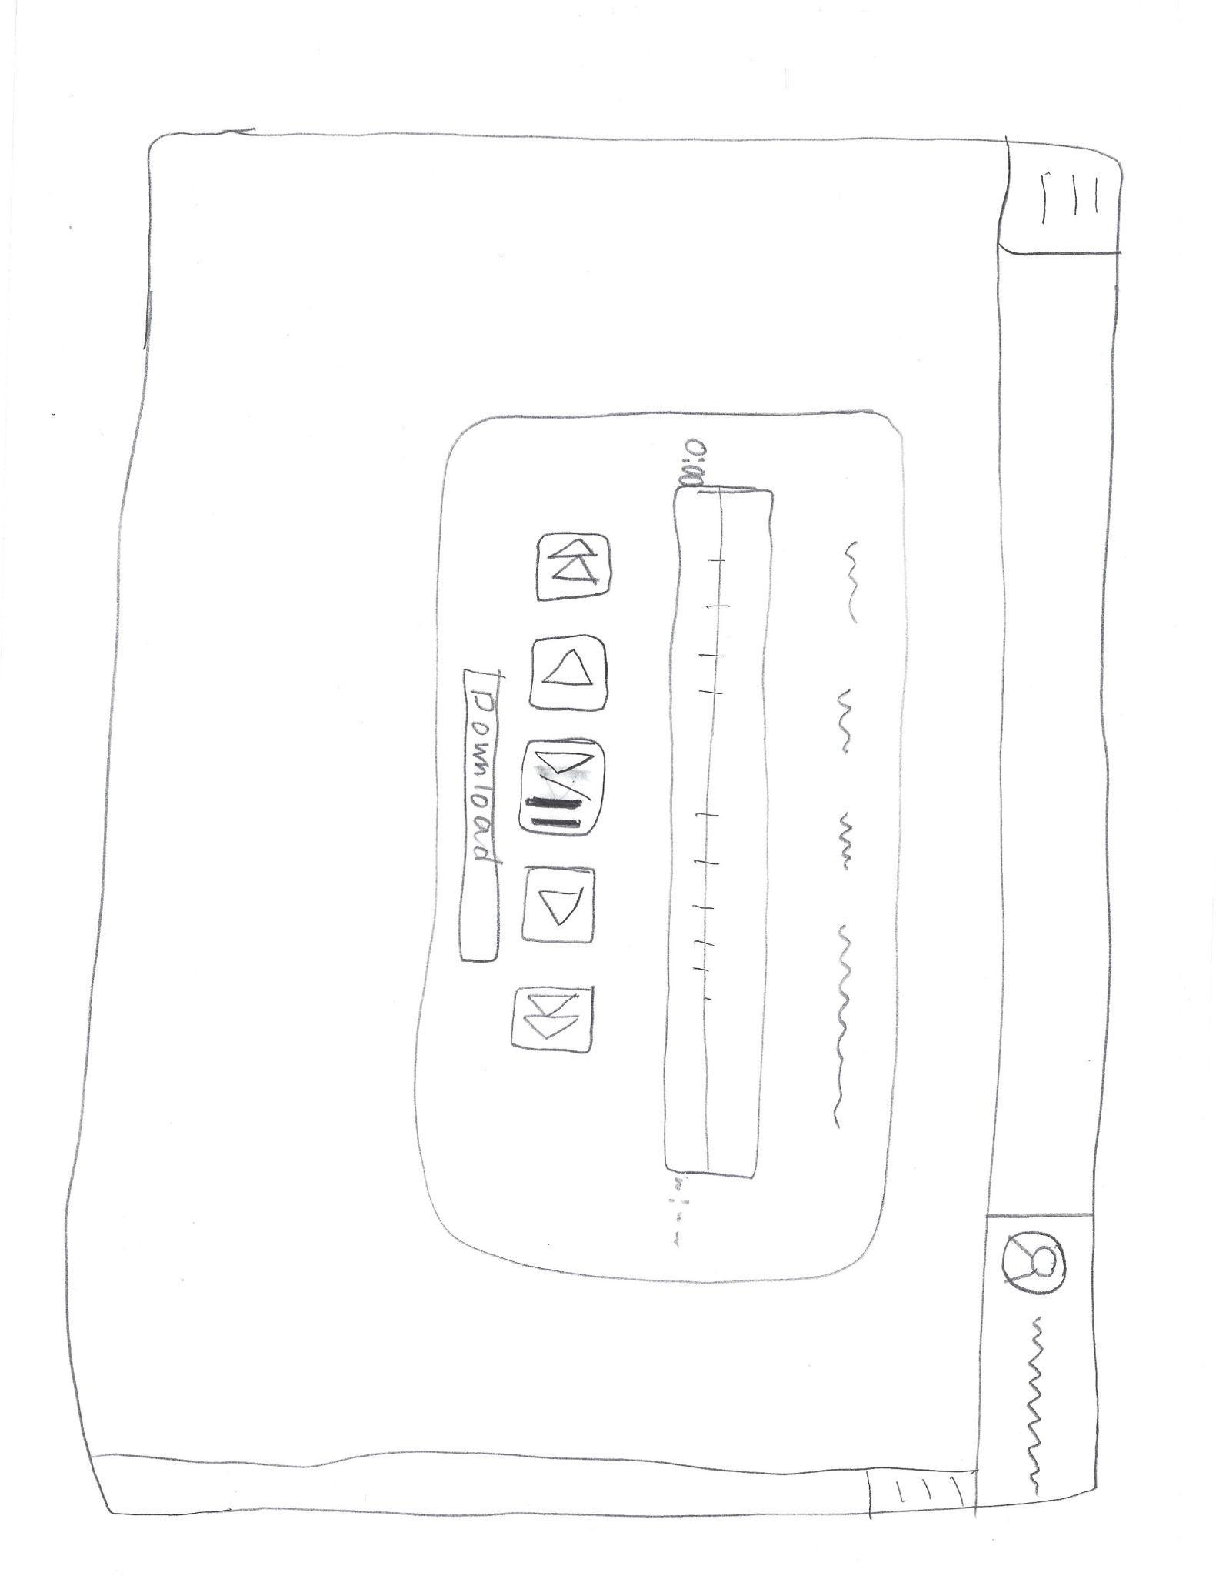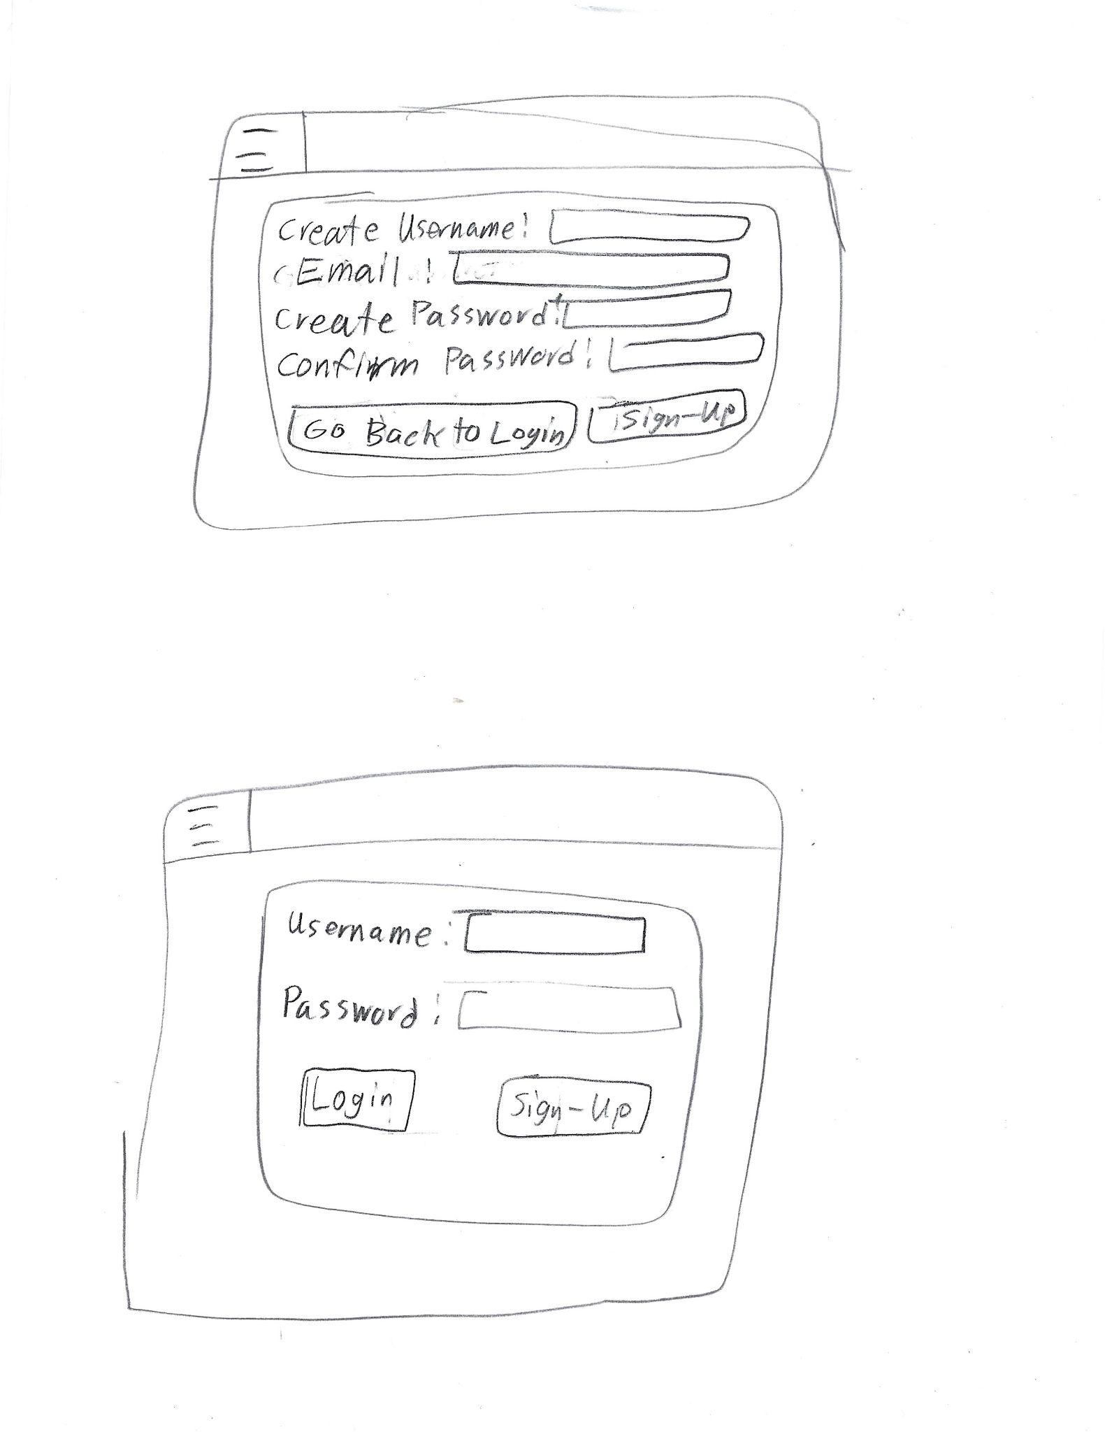

1. Procedural Design (Matthew Branstetter)

The user will first be greeted by a login screen asking for username and password before they can interact with the system. An SQL database will be queried for the username and password to let the user access the system if the input matches the data. Once inside, the user selects the mood of music-among other possible options made available-which will be predetermined buttons. After selecting the option(s) for the music to be generated the user will press a button to submit this information for music to be generated. With the options selected, the system will generate music with previous data/knowledge via machine learning to generate music for the user. Music will be created on a server and stored there as well. The path to the music will be saved to the SQL database and as such the music will be streamed from the server to the client for listening. If the user so pleases, they can download the music file from the server to their machine for listening later offline.

Data flow diagram for basic user login

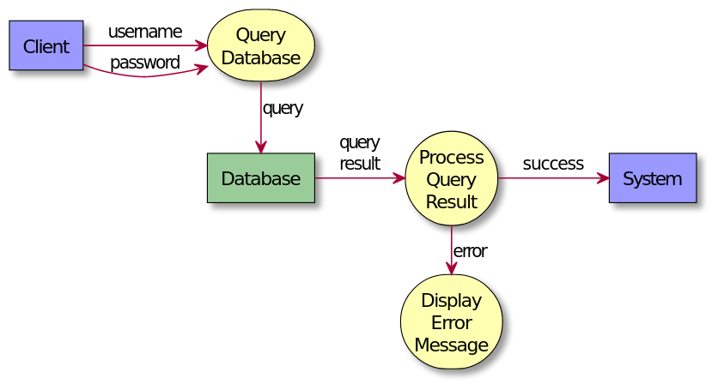

Data flow diagram for music generation and streaming

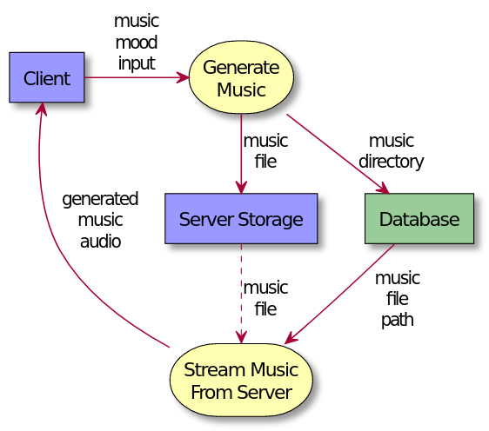

**Key Personnel**

Jonathan Hasty

10303 Judith Ct, Louisville, KY 502-389-3175 jmhasty@iu.edu

OBJECTIVE

To obtain a challenging position in the field of computer science that will allow me to expand my problem-solving and creative ability.

EDUCATION

Indiana University Southeast New Albany, IN

B.S. in Computer Science – Business Information Systems Degree expected: May 2022

Minor: Business GPA: 3.15

Saint Xavier High School Louisville, KY

Graduated: 2016

QUALIFICATIONS

· Strong problem solving and innovative thinking ability

· Effective communication skills – verbal, written, and listening

· Experience with an Agile approach to software development

TECHNICAL EXPERIENCE *(Projects)*

· The Legend of Zordo (2021): A top-down, action-adventure game developed in C++. This project stressed the importance of the ECS architectural pattern for game development.

· Needle in the Haystack (2020): A simple networked guessing game. This project utilized java socket programming for connectivity as well as the Swing framework for GUI design.

PROFICIENCIES

Languages

· Java

· C/C++

· Python

· SQL

Technologies

· VMware

· Git/ GitHub

· Docker

WORK EXPERIENCE

Lucky’s Market Louisville, KY

Deli Associate May 2018 – Jan. 2020

· Provided excellent customer service.

ADDITIONAL EXPERIENCE

· Eagle Scout (Boy Scouts of America)

**Jacob Coomes**

**6012 Heil Rd. Email: coomes.jacob@yahoo.com**

**Henryville, IN 47126 Phone: 812-252-9284**

**Objective:**

**Obtain position at SamTech as programmer**

**Employment History:**

**• Short Order Cook Dairy Queen**

**Sellersburg, IN**

**8/16/16-1/31/17**

**o Duties:**

**Utilize Grill and Deep Fryer to cook various types of food**

**Take the trash out**

**Clean up work area**

**• Wholesale Employee Walnut Ridge**

**Jeffersonville, IN 4/18/17-Present**

**o Duties**

**Water Plants**

**Put Merchandise in Customer’s Cars**

**Take out trash**

**Clean and weeded the Outside area**

**Landscape Assistance**

**Education:**

**Henryville High School**

**• Address: 213 N Ferguson St, Henryville, IN 47126**

**• 12th Grade**

**o Prossor:**

**o Computer Programming**

**HTML5**

**Visual Basic 6**

**Visual Basic 2010**

**Javascript**

**Indiana University Southeast**

**• Address: 4201 Grant Line Rd, New Albany, IN 47150**

**• Major: Bachelor Degree in Computer Science**

**• Minor: Math**

**• August 24, 2017 – Present Currently Junior**

**• Computer Programming**

**o F#**

**o C++**

**o Java**

**o Assembly Language**

**• General Education**

**o Calculus 1 & 2**

**o Speech**

**o Art**

**Academic Honors:**

**• Henryville High School National Honor Society**

**• Henryville High School Technical Diploma**

**Academic Scholarships:**

**• Henryville High School Key Club Award**

**• Orrin E Weber Special Effort Award**

**• The Terry Hill Higher Education Award**

**• Willis Drake Helping Hands Award**

**Volunteer Work**

**• Saint Francis Xavier Church**

**o Fish Fry**

**o Cleaning/ Maintenance**

**o Live Nativity**

**o Septemberfest**

**o Usher**

**o Halloween Trunk or Treat**

**Traits**

**• Hard-Working**

**• Focused**

**• Organized**

**• Trustworthy**

**SIMEON BRANSTETTER**

**Phone:** (812) 406-6814 || **Email:** matbrans@twc.com || **Github:** github.com/SimeonBranstetter

**Objective:** To obtain real world experience in my field of discipline that will enhance my skills in software engineering and application programming as well as computer architecture and data management.

**EDUCATION**

**Indiana University Southeast – New Albany, IN** May 2021

Bachelor of Science in Computer Science – Math & Science Track GPA 3.7/4.0

Minor in Mathematics

**Relevant Coursework:**

**Completed:** Object Oriented Programming, Discrete Mathematics, Computer Structures, Data Structures, Programming Languages, Software Engineering, Computer Networking, Analysis of Algorithms, Calculus 1, Calculus 2, Calculus 3, Linear Algebra, Elements of & Probability

**Additional Coursework:**

**Completed:** Survey of Economic Issues & Problems, Public Speaking, Reading-Writing & Inquiry, Writing in the Arts & Sciences, Principles of Chemistry, Experimental Chemistry

**PROJECTS AND EXPERIENCE**

**IUS Software Engineering Class Group Project** January 2020 – May 2020

* Small development team using RESTful and other architectural styles for application programming in a team to create an application.
* Using Kotlin via android studio a phone application was programmed to read album records from taking a picture of the cover and then sending back pertinent information of the album including songs, writers, producers, etc.
* Google Cloud API was used for the image recognition along with the Discogs API and database for searching up the appropriate album info from the parsed data received from Google Cloud API.

**IUS Computer Networking Class Group Project** August 2020 – December 2020

* Small development team using language, IDE, API/Framework of choice to develop a game that would use networking capabilities for internet communication via 2 or more players.
* Lua via Sublime Text Editor along with a Lua 2d game creation API called LOVE Engine was used to develop a crude version of Battleship using UDP socket connections for internet communication.

**Clark County Indiana 4-H Robotics Club** February 2013 - July 2019

* Physically constructed and programmed with Lego Mindstorms in a group to understand basic robotics, engineering, and programming knowledge.
* Last couple of years spent as a club leader for the robotics group teaching children about basic programming knowledge along with hardware communication.

**SKILLS**

**Languages:** Proficiency in Java, C++ || Comfortable with F#, Lua || Worked with Python, C#, C, Kotlin

**Dev Tools:** Git, IntelliJ IDEA, Netbeans, Visual Studio Code

**AWARDS/HONORS**

**Chancellor’s List - Two Semesters** || **Dean’s List - Two Semesters**